# Detailed Video Analysis:

**The Adventure That Saved My Life.**

[**https://www.youtube.com/watch?v=tWCLD8wmBs8&t=31s**](https://www.youtube.com/watch?v=tWCLD8wmBs8&t=31s)

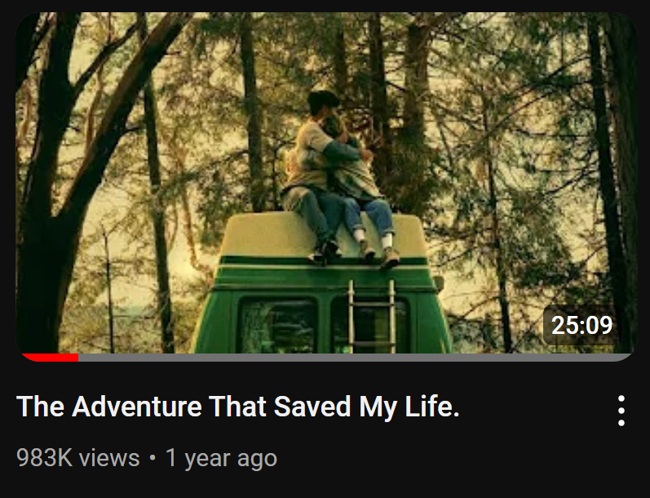

# Introduction:

**“The Adventure That Saved My Life” is** a YouTube video created by Natalie Lynn who is a living in a caravan lifestyle youtuber who shows her life living and traveling to various places in USA.

The main theme of this video is how she was alone and emotionally distant from people after someone close to her broke her heart and how she overcome those feelings after making new friends and travelling more.

The purpose of this video is to show the views her story and the journey she went through these explorations.

Thesis Statement:

# Visual Elements:

The use of camera angle, lights, colors, and composition in this 25 mins long video is just exceptional, better than 90% of other YouTube video and even better than some of the top graded movies.

The intro of the Video starts with muffled voices singing and dancing in front of their truck with the headlights turned on at the night. This created a rim light and hair light for both character and they were dancing and since everything else is dark it also created a silhouette of the people dancing.

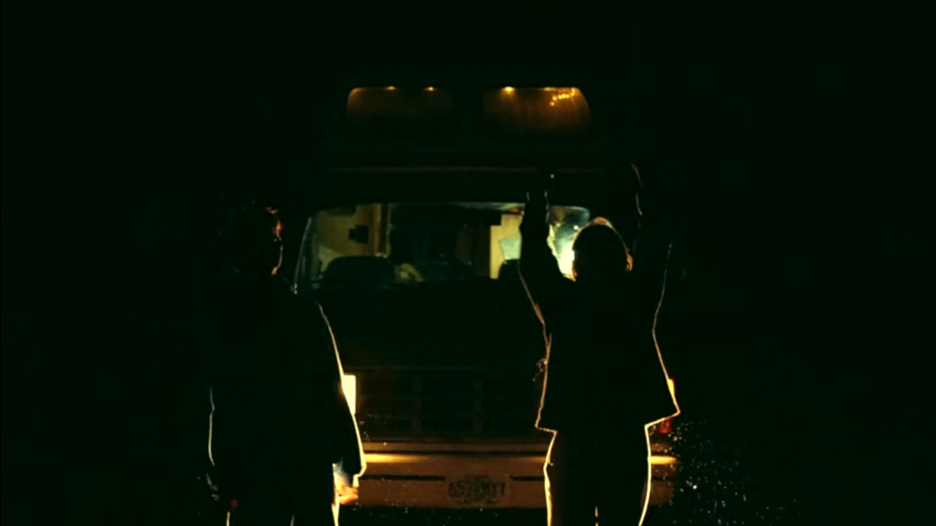

Second sequence of video starts as she says, ‘I didn’t know it in this moment, but everything was about to end.’ And series of perfectly composed shots of her travelling are show with cuts with the base piano music.

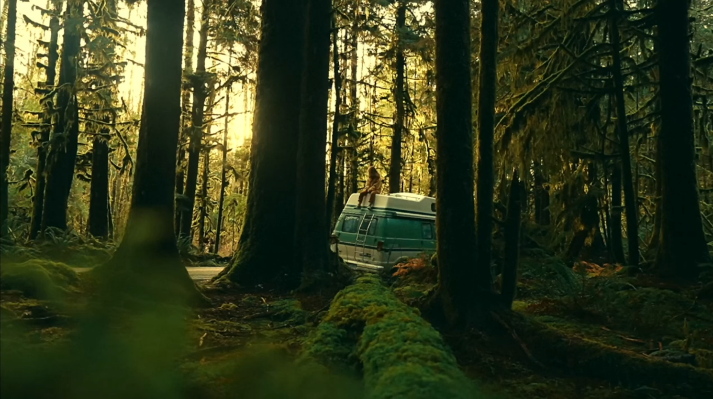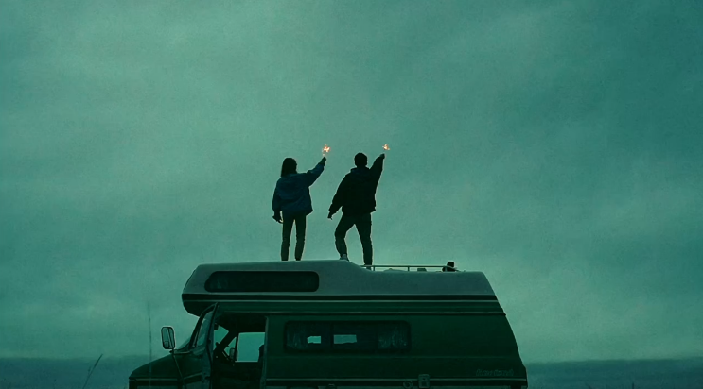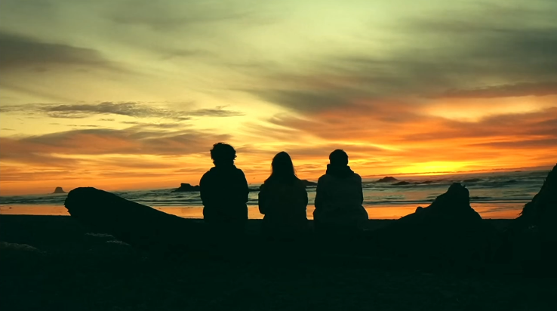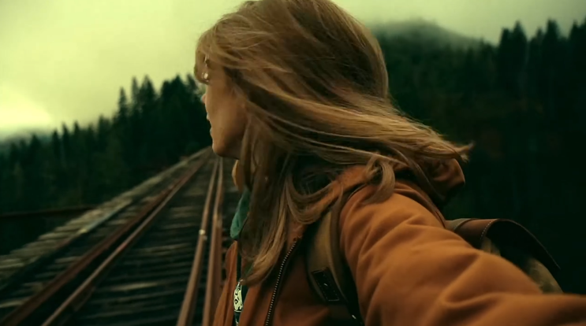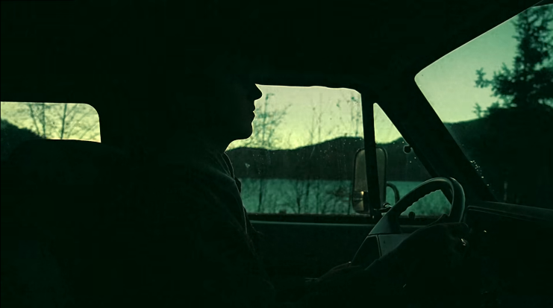 I love how these sequences of short videos show how in one frame she is with her friends enjoying and in another she is all alone looking for something.

She says, ‘I know nothing in life is meant to last forever.’

‘Everything eventually ends in one way or another.’

When she says ‘Everything eventually ends in one way or another’ there is a top-down drone shot of the drone flying away from her and she is sitting on the wings of a broken plane in this random jungle.

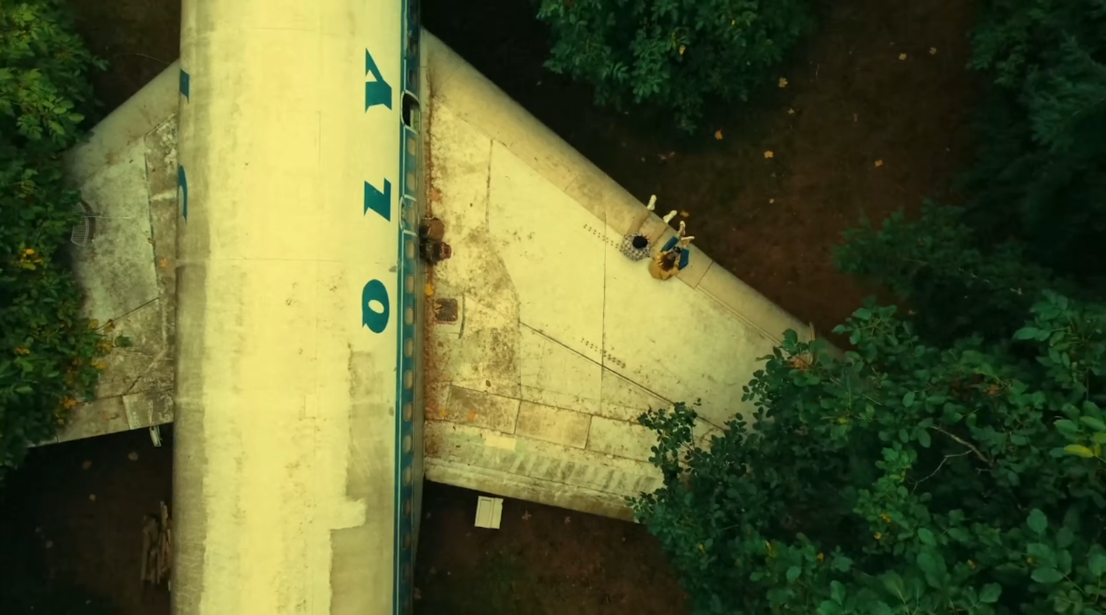

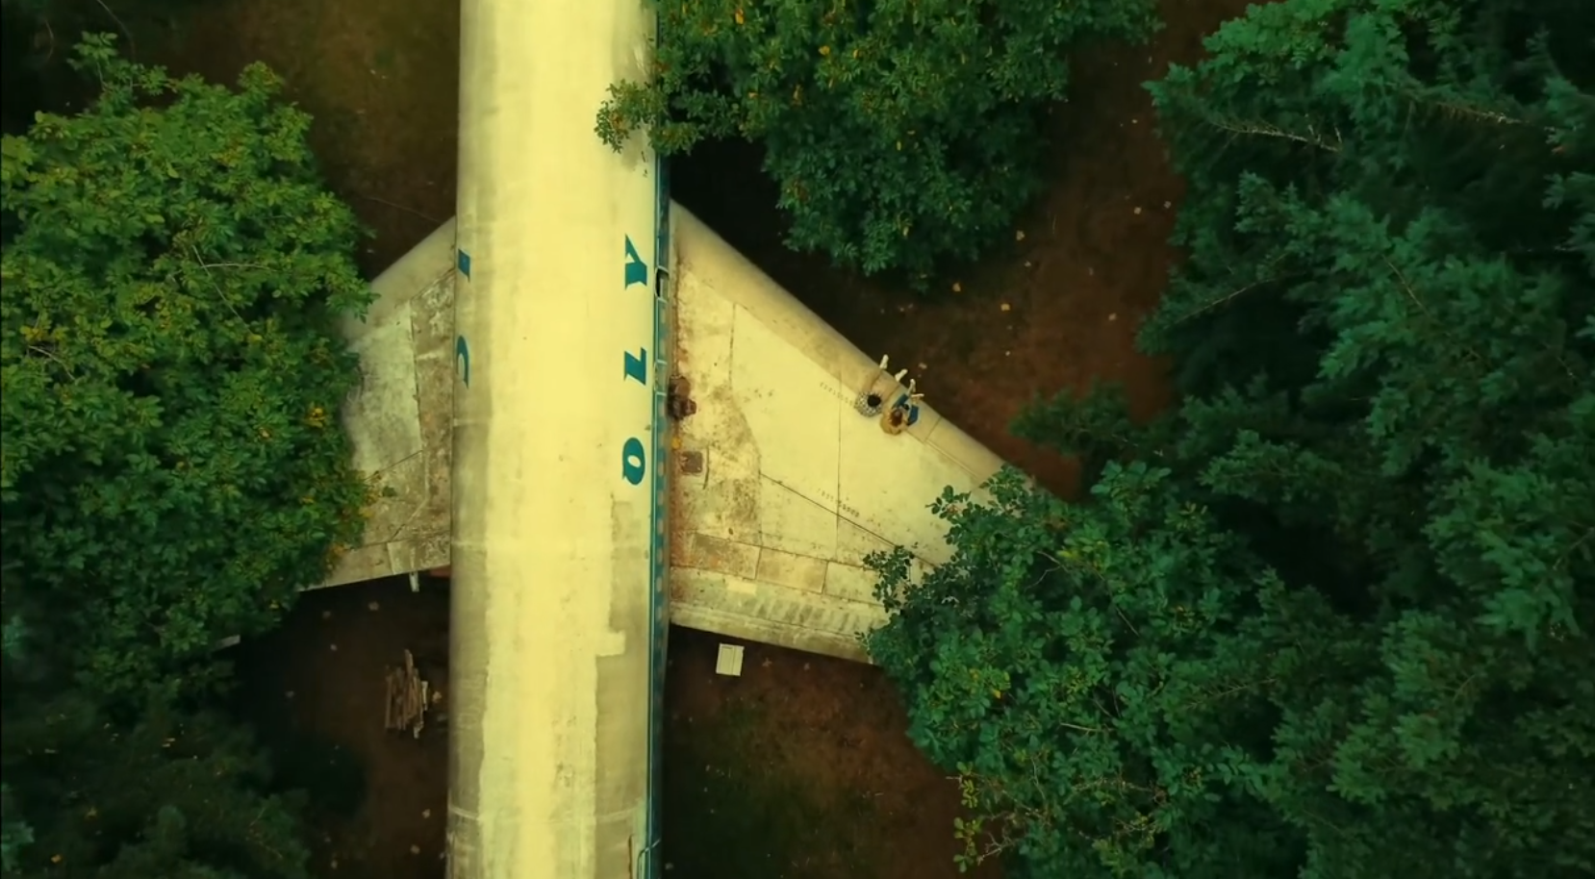

And she says, ‘And that is the beauty of it all. Life really Is this series of fleeting moments emotions and experiences.’ With more short clips of her travelling alone and with friends.

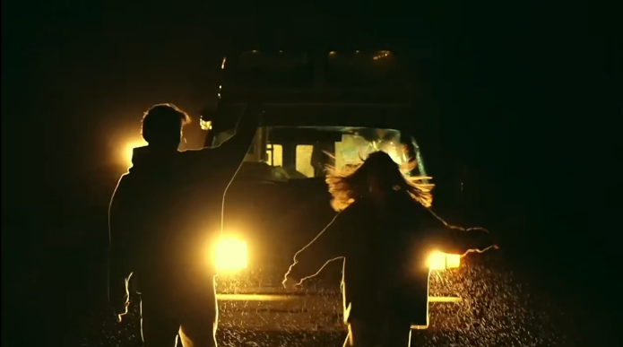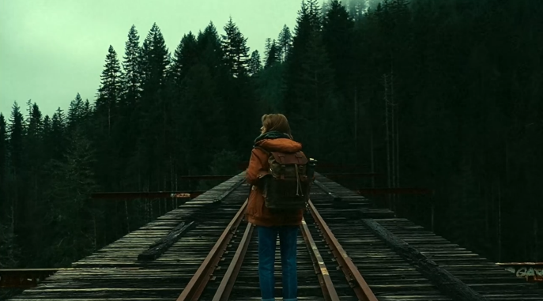

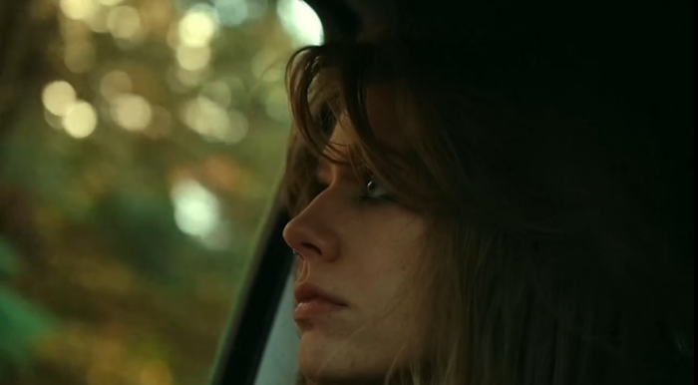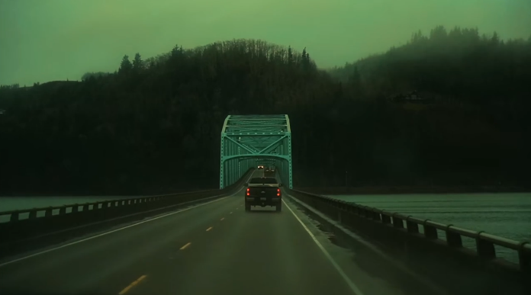

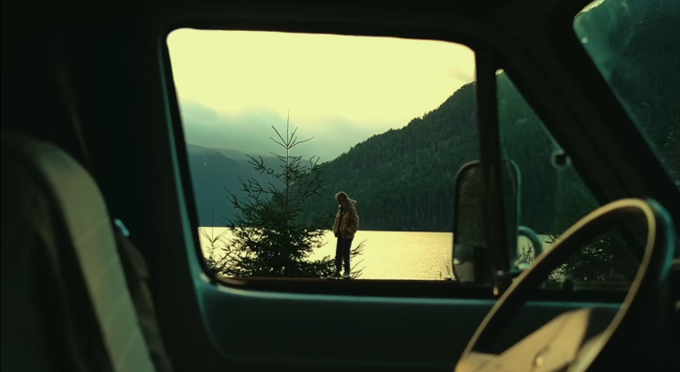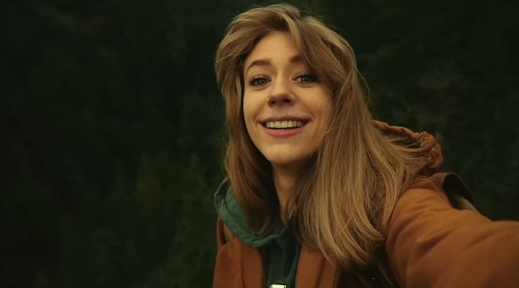

At the end she says, ‘I just guess I just could have never imagined this all ending in the way it did.’

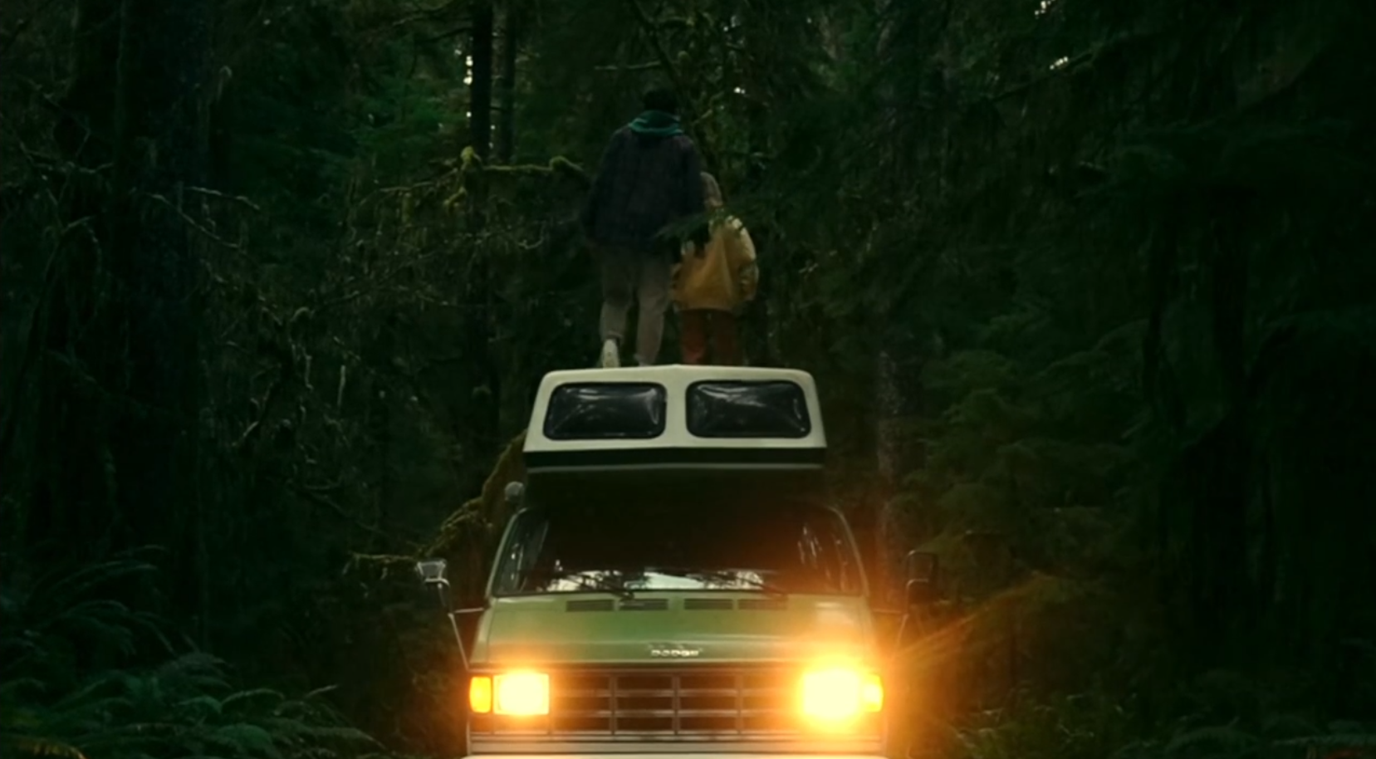

And as she says this all ending in the way it did, the headlights turn off as well.

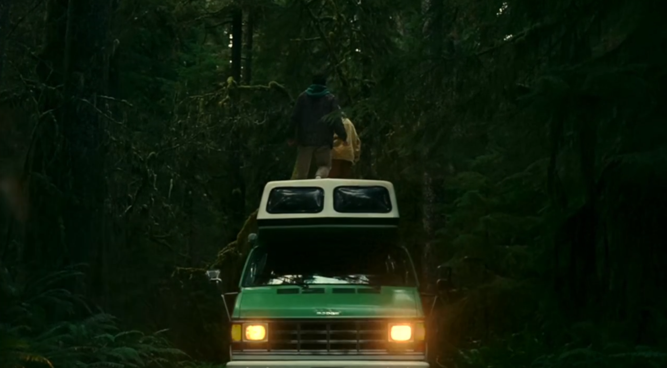

# Sound Elements

* Explore the use of music, sound effects, and dialogue.

Editing Techniques

* Analyze pacing, transitions, and special effects

# Symbolism & Metaphors

* Identify symbolic elements and deeper meanings

# Overall Impact

* Evaluate the effectiveness of the video in achieving its goal

# Conclusion

* Summarize your key findings and provide personal reflections